

**DEDAN KIMATHI UNIVERSITY OF TECHNOLOGY**

**DEPARTMENT OF ELECTRICAL AND ELECTRONIC ENGINEERING**

**STUDENT PROJECT LOGBOOK**

This logbook is intended to assist final-year students in managing their project research effectively and for completion within the stipulated time. Therefore, all students must document summaries of research activities **every week** and submit the logbook to the supervisors **twice a month** in the format prescribed below.

The summary of activities entered must be a verifiable record jointly agreed upon by you and your supervisor.

**Student Details:**

|  |  |  |  |
| --- | --- | --- | --- |
|  | **Registration Number** | **Name** | **Signature** |
| **1.** | **E021-01-0694/2019** | **ERIC MULWA** |  |
| **2.** | **E021-01-0716/2019** | **ESTHER MUKITE** |  |
| **3.** | **E021-01-0693/2019** | **TOM NDOLO** |  |

Undergraduate Programme: ..........................................................................................................................

Project Title: ..................................................................................................................................................

..................................................................................................................................................................................................................................................................................................................................................................................

**RESEARCH ACTIVITIES**

**Month &Year: September 2023**

|  |  |
| --- | --- |
| **Date:** | **Research activities** |
| **14TH SEP 2023** | Researched on how to interface L298N motor driver Module with a DC Motor and Arduino Uno. Connected the setup and developed a program to execute the operation. The setup responded as programmed. |
| **14TH SEP 2023** | Researched on how to program STM32 Microcontrollers using the Arduino IDE, STM32CubeIDE and Keil uVision. Developed different programs in the three development environments and imported them for a setup in Proteus for simulation. |
| **15TH SEP 2023** | Developed I2C and SPI communication protocol libraries for STM32 microcontrollers using the Arduino IDE. Adapted the Arduino Setup Program with L298N Motor Driver and DC Motor to work with the STM32F103C8T6 Microcontroller using the STM32Duino. The setup worked as expected. |
| **15TH SEP 2023** | Interfaced STM32F103C8T6 Microcontroller with L298N motor driver Module, DC Motor and Relay Module. The Relay Module and the Motor were connected on the L298N driver for power and signals coming from the STM32. |
| **16TH SEP 2023** | Researched on interfacing Arduino UNO with GSM SIM7600CE 4G Module and connected the setup and programmed it to send and receive SMS and display them on the serial monitor of the IDE. The setup was challenging but, in the end, we managed to get it working. |
| **Summary of Activities:**  In conclusion, we successfully interfaced Arduino UNO and STM32F103C8T6 with L298N Motor Driver, DC Motor and Relay Module controlling an LED connected at pin PA1 of the STM32 and Digital pin 3 of the UNO in the week ending 16th September 2023. We also delved into GSM SIM7600CE 4G Module communication protocol and its interface with Arduino UNO and successfully managed to initiate text message communication between the module and a smartphone. | |

Student 1 Signature: ..................................................... Date: .................................................

Student 2 Signature: ..................................................... Date: .................................................

Student 3 Signature: ..................................................... Date: .................................................

**RESEARCH ACTIVITIES**

**Month &Year: September 2023**

|  |  |
| --- | --- |
| **Date:** | **Research activities** |
| **21ST SEP 2023** | Researched on the how to interface GSM SIM7600CE Module with STM32F103C8T6 in STM32CubeIDE. Focused specifically on Uhart Communication Protocol of the STM32 Microcontrollers in the STM32CubeIDE environment and Arduino IDE. |
| **21ST SEP 2023** | Interfaced STM32F103C8T6 microcontroller with the GSM SIM7600CE 4G Module to control an LED Connected at Pin PA1. The GSM was able to receive the SMS from the smartphone and pass the commands to the STM32. The STM32 executed the commands as intended and we were able to switch the LED On and Off via SMS Communication protocol. |
| **22ND SEP 2023** | Interfaced STM32F103C8T6 microcontroller with the GSM SIM7600CE 4G Module to send SMS to a smartphone when a button connected at Pin PB12 was pressed. The set was able to execute the intended purpose and were able to change the receiver phone numbers in the code and no difficulties were encountered. |
| **22ND SEP 2023** | Combined and modified the two STM32F103C8T6 programs; “Sending SMS” and “Receiving SMS”, to Control DC Motor and the Relay Module via the L298N Driver. The programs were modified to send the command “syson” to switch on the motor and the relay module respectively and “sysoff” to switch off the Relay Module and the DC Motor respectively. The setup worked perfectly. |
| **23RD SEP 2023** | Designed Wireless Power Transfer Coils using a 0.3mm insulated copper wire and tested the induction process using Oscilloscope after powering the coils using a Function Generator. The setup was able to transfer power wirelessly within the range of 1mm – 400mm separation distance at 1kHz 20V ac frequency supply. |
| **Summary of Activities:**  In summary, during the week ending 23rd September 2023, the group managed to successfully interface STM32F103C8T6 microcontroller with GSM SIM7600CE 4G Module, L298N Motor Driver, DC Motor and Relay Module. The group was also able to conduct WPT using ring coils in the Machines Lab using a Function generator and an Oscilloscope. The Induction procedure was a success at a separation distance ranging 1mm – 400mm powered at 1kHz 20V ac frequency supply. | |

Student 1 Signature: ..................................................... Date: .................................................

Student 2 Signature: ..................................................... Date: .................................................

Student 3 Signature: ..................................................... Date: .................................................

**Additional Information**

*This page is for any additional work you need to share that does not fit the weekly description from the two weeks above.* ***Limit to not more than the space provided below.***

The main objective for the first two weeks was to develop segments of codes for each and every component to be connected to the Smart EV Wireless Charging System Transmitter section. The Transmitter (Tx) section of the SevWCS system will consists of the STM32F103C8T6 Microcontroller, GSM SIM7600CE Module, Motor Driver L298N, 12V DC Motor, Relay Module and two IR Receiver Sensors. So far, the group has managed to developed a complete bug free working program for the STM32F103C8T6 interface with GSM SIM7600CE 4G Module, Motor Driver L298N, 12V DC Motor, Relay Module. What remains as per the proposal is to add IR Sensor Receivers to the Setup to enable control of the system using MFRC522 RFID module tags programmed to control IR Sensor Transmitter connected at the Receiver (Rx) Section of the System. This is yet to be developed but as time goes by a progress of the same will be shared in the following pages.

The Transmitter and the Receiver WPT Coils were also designed and tested for different Number of turns and separation distances. The group was able to confirm that at 10mm separation distance and 1kHz 20V ac frequency supply, the Receiver coils connected to the Oscilloscope received induced voltage of 11.9 V. This experiment confirmed that at 10mm separation distance for a real SevWCS System, the Electric vehicle connected to the system will be able to receive 59.5% of the supply power. This efficiency can be improved to almost 85% by deploying LC tanks and high efficiency WPT Coils.

Pictures and videos showing the demonstration are available on request.

**Comments by supervisor**

Name: .........................................................................................................

Comments:.............................................................................................................................................................................................................................................................................................................................................................................................................................................................................................................................................................................................................................................................................

Signature: ...................................................... Date: ..............................................................

**RESEARCH ACTIVITIES**

**Month &Year: September 2023**

|  |  |
| --- | --- |
| **Date:** | **Research activities** |
| **28TH SEP 2023** | Researched on how to interface Arduino Uno with IR sensor and connected the setup to test its functionality. The developed program was able to detect when an obstacle blocked the sensor and indicate by powering an LED connected to digital pin D9. |
| **28TH SEP 2023** | Adapted the Arduino Uno program to work with the STM32F103C8T6 microcontroller. The adapted program was able to execute the same operation and it was ready to be modified for the real application in the SevWCS system. |
| **29TH SEP 2023** | Developed another program for the STM32F103C8T6 with IR Sensor Receivers connected at pins PA8 and PA1. The programmed was combined with the previous STM32F103C8T6 interfaced with GSM SIM7600CE, L298N Motor Driver, Dc Motor and Relay Module program. This new program was intended to provide a second control option to switch ON and OFF the SevWCS system. The program was designed to allow the IR receiver connected at pin PA1 to power on the system when it received an infrared signal from the first IR Transmitter connected at Digital pin D4 in the Receiver (Rx) section of the SevWCS. |
| **29TH SEP 2023** | The IR receiver connected at pin PA8 was to switch off the system when an infrared signal was received from the Second IR Transmitter connected at Digital pin D5 in the Receiver (Rx) section of the SevWCS. The program also allowed for the GSM SMS control protocol and was mitigated against any loopholes and bugs. |
| **30TH SEP 2023** | The program was then uploaded to the setup and tested. The group was able to successfully control the switching ON and OFF of the system using IR transmitters connected at the Receiver microcontroller and GSM SIM7600CE SMS protocol. The setup worked as intended and video showing the demonstration was recorded and stored for review. |
| **Summary of Activities:** | |

Student 1 Signature: ..................................................... Date: .................................................

Student 2 Signature: ..................................................... Date: .................................................

Student 3 Signature: ..................................................... Date: .................................................

**RESEARCH ACTIVITIES**

**Month &Year: October 2023**

|  |  |
| --- | --- |
| **Date:** | **Research activities** |
| **5TH OCT 2023** | Researched on how to interface MFRC522 RFID Module with Arduino Uno for the Rx Setup of the SevWCS. Developed a program to interface Uno and RFID and uploaded the program into the setup and tested by scanning two tags with different UID to switch On and Off an LED Connected to D8. The setup worked as intended. |
| **5TH OCT 2023** | Researched on how to interface Arduino Uno with 1602 LCD Display for displaying when system is switched on or off. Developed a program for the interface and uploaded it into the setup and executed it. The program was able to display the defined texts in the code under the specified conditions. |
| **6TH OCT 2023** | Interfaced Arduino Uno with IR Transmitters connected at digital pins D4 and D5 respectively. Programmed the sensors to transmit infrared signals whenever a specific RFID tag was scanned. These signals would later be used to power on and off the Tx section of the system via the IR Receivers connected at pins PA1 and PA8 in the STM32F103C8T6. |
| **6TH OCT 2023** | Combined the programs for Arduino Uno interfaced with MFRC522 RFID, 1602 LCD Display and the Two IR Transmitters into one program to be used in the Rx section of the SevWCS System. The combined and modified program worked as expected. |
| **7TH OCT 2023** | Connected the STM32F103C8T6 interfaced with GSM SIM7600CE, L298N Motor Driver, Dc Motor, Relay Module and the Two IR receiver’s setup and the Arduino Uno interfaced with MFRC522 RFID, 1602 LCD Display and the Two IR Transmitters setup. The group then tested the compatibility of the two setups by scanning RFID tags. The two setups were not connected together but used infrared signals to communicate with each. The group was able to switch On and OFF the Tx system using different RFID tags scanned at the Rx system. The setup also responded to the GSM SIM7600CE SMS commands accordingly. |
| **Summary of Activities:** | |

Student 1 Signature: ..................................................... Date: .................................................

Student 2 Signature: ..................................................... Date: .................................................

Student 3 Signature: ..................................................... Date: .................................................

**Additional Information**

*This page is for any additional work you need to share that does not fit the weekly description from the two weeks above.* ***Limit to not more than the space provided below.***

**TRANSMITTER SECTION OF THE SYSTEM (Tx)**

The Transmitter (Tx) section of the SevWCS system consists of the STM32F103C8T6 Microcontroller, GSM SIM7600CE Module, Motor Driver L298N, 12 DC Motor, Relay Module and two IR Receiver Sensors. The group has been working on the Setup program for a while and it has managed to control the Tx setup using the GSM Module and RFID controlled Receiver IR sensors. The First IR Receiver sensor is for turning OFF the system when a signal is received from the first Transmitter IR sensor in the Receiver section of the System (Rx). The second IR Receiver Sensor is for turning ON the system when a signal is received from the second Transmitter IR sensor in the Receiver section of the System (Rx). The IR transmitters are controlled by the RFID scan tags in the Receiver system. When you scan the “Power On” tag, the Rx system commands the Second IR sensor transmitter and produces an infrared signal which is received by the second Tx IR Receiver. This signal is then executed as follows; the DC Motor is first switched on and rotated in the clockwise direction for three seconds. It is then switched off and the Relay module powered on. The implication here is, the motor rotates in the clockwise direction to move the induction coils up 10mm near the receiver induction coils of the electric vehicle on station. The Relay Module then receives a HIGH signal from the controller to switch on power supply to the coils and the charging process is initiated.

When you scan the “Power OFF” tag, the Rx system commands the first IR sensor transmitter and produces a signal which is received by the first Tx IR Receiver. This signal is then executed as follows; the relay receives a LOW signal from the microcontroller which switches OFF power supply and then the DC Motor is switched On and rotated in the counter clockwise direction for three seconds. This process moves the Tx coils setup down to the initial point which clears the visual clutter under the electric vehicle. The Tx system can also be controlled via SMS commands from the GSM SIM7600CE Module. When the Sim7600CE Module receives the SMS “syson” from the user, it is executed as follows; the DC Motor is switched on and rotated in the clockwise direction for three seconds and then switched off before turning on the relay module and connecting power to charge the Electric Vehicle on station. When the SIM7600CE GSM Module receives the SMS "sysoff", it executes it by turning OFF the relay module which disconnects power from the Electric Vehicle on station before rotating the DC Motor in the anticlockwise direction for two seconds to move the system down to its rest position. This is the entire functionality of the SevWCS Tx. The setup will be clearly demonstrated in the final prototype setup using the Electric Bus model and a parking station model. The Tx program is fully developed and tested. It includes 150 lines of code with all the bugs and loopholes mitigated.

**RECEIVER SECTION OF THE SYSTEM (Rx)**

The Rx of the system consists of Arduino Uno, MFRC522 RFID Module, 1602 LCD Display, two IR Transmitter Sensors and a Simple Battery management system. The setup is a work in progress but the group has managed to develop the entire program for the Rx. The SevWCS Rx setup works as follows; when you scan the “Power On” RFID tag, the program in the microcontroller sets the First IR Transmitter sensor high for three seconds. This transmitter produces an infrared signal which is targeted at the First IR Receiver sensor in the SevWCS Transmitter. When this signal is received in the Transmitter System, it is executed to power on the system and charging is initiated. This process is done procedurally by first connecting the DC motor to move the system up before switching on the power supply. When the system starts to charge, the 1602 LCD displays “System Power On, EV Charging”. This text is initiated by reading the state of Pin D3 which is connected to the Rx Coils. So, in the event the Tx system has no power or it is switched off, even if the Rx is switched on, The LCD will not display anything because it will not detect any signal from the Rx coils. This measure gives the SevWCS users a 100% guarantee that the vehicle is charging when they see that text on the LCD.

When you scan the “Power OFF” RFID tag, the program in the microcontroller sets the Second IR Transmitter sensor high for three seconds. This transmitter produces an infrared signal which is targeted at the Second IR Receiver sensor in the SevWCS Transmitter (Tx). When this signal is received in the Transmitter System, it is executed to power off the system and charging is terminated. This process is done procedurally by first disconnecting the power supply and then moving the system down to its initial rest position. Once the Tx system is switched off and there is no power supply, the 1602 LCD displays “System Power Off, EV Disconnected” to show that the vehicle charging process has been interrupted due to unavoidable circumstances. This feature provides the users of the system the freedom to pick their electric vehicles at any point of charge percentage if need be.

Now when the system is allowed to charge without any interruption, it will continue charging until the Electric Vehicle Battery Management System stops the charging when the battery is fully charged. To stop the charging, the BMS sends a signal to Pin D2 which is set as an input pin. When this signal is received in the Rx system, it is executed by setting the Second IR Transmitter sensor high for three seconds. This transmitter produces an infrared signal which is targeted at the First IR Receiver sensor in the SevWCS Transmitter. When this signal is received in the Transmitter System, it is executed to power off the system and charging is terminated. Once the Tx system is switched off and there is no power supply, the 1602 LCD displays “System Power Off, EV Fully Charged” to show that the vehicle has charged to its capacity without any interruptions and the system has disconnected it from power. The Tx system then automatically sends the message “EV No.X is Fully Charged and Disconnected from Power” to the parking lot attendant. The parking lot attendant can then inform the owner to pick the vehicle and clear the charging station for another user.

**Comments by supervisor**

Name: .........................................................................................................

Comments:.............................................................................................................................................................................................................................................................................................................................................................................................................................................................................................................................................................................................................................................................................

Signature: ...................................................... Date: ..............................................................

**For Official Use (MONTHLY)**

**Progress Presentation 1 Comments:**

**Comments by Project Coordinator:**

Name: .........................................................................................................

Comments:.............................................................................................................................................................................................................................................................................................................................................................................................................................................................................................................................................................................................................................................................................

Signature: ...................................................... Date: ..............................................................

**RESEARCH ACTIVITIES**

**Month &Year: October 2023**

|  |  |
| --- | --- |
| **Date:** | **Research activities** |
| **12TH OCT 2023** | Researched on 3D design using AutoCAD MEP and 3D printing using Ender 3 V2 3D printing Machines. The parts to be designed using AutoCAD MEP software include the following; Rack Extrusion Tube, Rack and Coil holder, Pinion gear, Pinion gear shaft and Electric Bus model Wheels and their shafts. |
| **12TH OCT 2023** | Designed an Electric Bus Model for hosting the Rx section of the SevWCS system. The model measures 300mm by 100mm by 150mm. A picture of the same is available on request. |
| **13TH OCT 2023** | Started 3D design of the above-mentioned parts for the deployment of the SevWCS Prototype. The Rack Extrusion Tube and Rack and Coil holder were first designed and exported as stereo lithography files (.stl). These files will later be used in the Creality Slicing software to generate g-codes for the Ender 3 V2 3D printing Machine. |
| **13TH OCT 2023** | Designed the Pinion gear, Pinion gear shaft and Electric Bus model Wheels and their shafts. Exported the files as stereo lithography files (.stl). Imported all the stereo lithography files into the Creality Slicing Software and generated g-codes for each assembly part. The g-codes are ready for 3D Printing as of now. |
| **15TH OCT 2023** | Designed the 3D deployment wooden board in AutoCAD MEP for visualization aid during fabrication in the Institution Workshop. The board measures 400mm by 800mm by 200mm. A picture of the same is available on request. |
| **Summary of Activities:**  In summary, for the week ending 15th October 2023, the group delved into 3D design of major assembly parts of the SevWCS system. The parts were carefully designed following all the measurements keenly and their respective stereo lithography files and g-codes generated accordingly. The group also designed and fabricated an Electric Bus Model using cartons to host the Rx section of the SevWCS. | |

Student 1 Signature: ..................................................... Date: .................................................

Student 2 Signature: ..................................................... Date: .................................................

Student 3 Signature: ..................................................... Date: .................................................

**RESEARCH ACTIVITIES**

**Month &Year: October 2023**

|  |  |
| --- | --- |
| **Date:** | **Research activities** |
| **19TH OCT 2023** |  |
| **19TH OCT 2023** |  |
| **20TH OCT 2023** |  |
| **21ST OCT 2023** |  |
| **22ND OCT 2023** |  |
| **Summary of Activities:** | |

Student 1 Signature: ..................................................... Date: .................................................

Student 2 Signature: ..................................................... Date: .................................................

Student 3 Signature: ..................................................... Date: .................................................

**Additional Information**

*This page is for any additional work you need to share that does not fit the weekly description from the two weeks above.* ***Limit to not more than the space provided below.***

**MECHANICAL SECTION OF THE SYSTEM**

To implement the prototype, a demonstration using several mechanical designs will be used. To complete this section, we have designed an Electric Bus Model to be used for the charging demonstration. The Transmitter and Receiver coils are also ready and we tested them. We were able to transmit power wirelessly and the setup is as shown below.

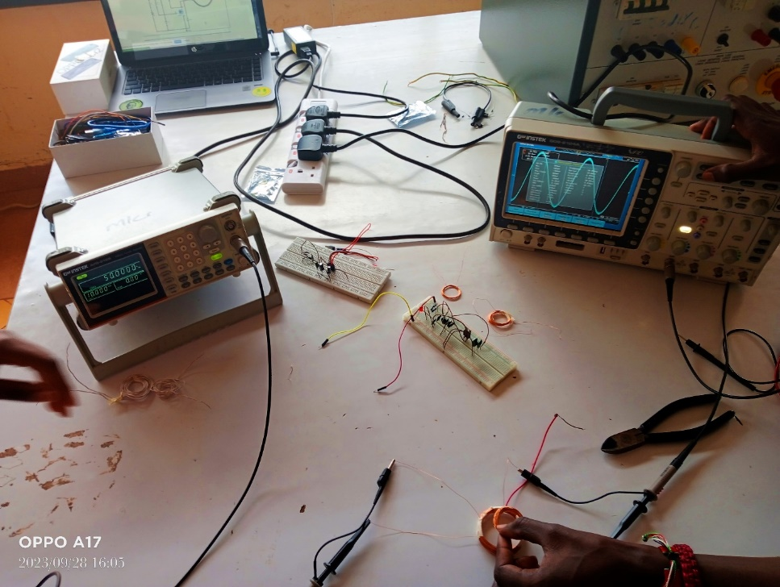 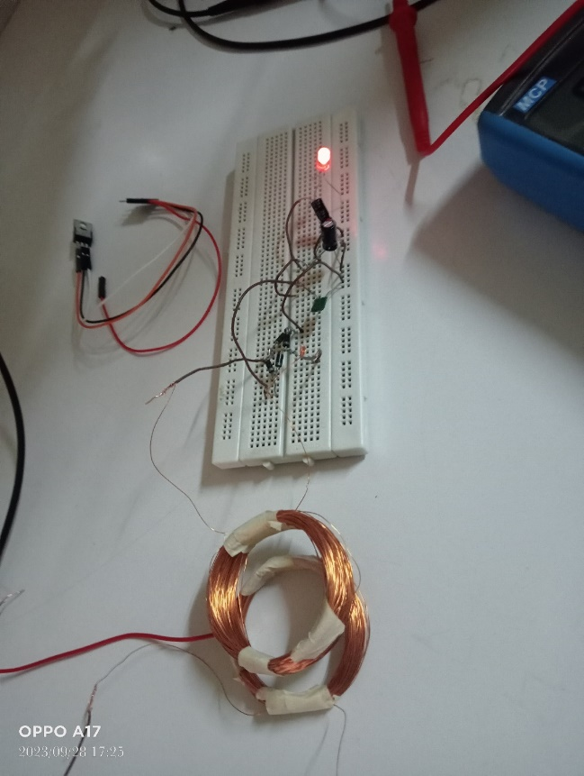

The different mechanical parts of the system have been designed in AutoCAD MEP and are ready for 3D printing. They include; Rack Extrusion Tube, Rack and Coil holder, Pinion gear, Pinion gear shaft and Electric Bus model Wheels and their shafts.

**Comments by supervisor**

Name: .........................................................................................................

Comments:.............................................................................................................................................................................................................................................................................................................................................................................................................................................................................................................................................................................................................................................................................

Signature: ...................................................... Date: ..............................................................

**RESEARCH ACTIVITIES**

**Month &Year: October 2023**

|  |  |
| --- | --- |
| **Date:** | **Research activities** |
|  |  |
|  |  |
|  |  |
|  |  |
|  |  |
| **Summary of Activities:** | |

Student 1 Signature: ..................................................... Date: .................................................

Student 2 Signature: ..................................................... Date: .................................................

Student 3 Signature: ..................................................... Date: .................................................

**RESEARCH ACTIVITIES**

**Month &Year: October 2023**

|  |  |
| --- | --- |
| **Date:** | **Research activities** |
|  |  |
|  |  |
|  |  |
|  |  |
|  |  |
| **Summary of Activities:** | |

Student 1 Signature: ..................................................... Date: .................................................

Student 2 Signature: ..................................................... Date: .................................................

Student 3 Signature: ..................................................... Date: .................................................

**Additional Information**

*This page is for any additional work you need to share that does not fit the weekly description from the two weeks above.* ***Limit to not more than the space provided below.***

**Comments by supervisor**

Name: .........................................................................................................

Comments:.............................................................................................................................................................................................................................................................................................................................................................................................................................................................................................................................................................................................................................................................................

Signature: ...................................................... Date: ..............................................................

**For Official Use (MONTHLY)**

**Progress Presentation 2 Comments:**

**Comments by Project Coordinator:**

Name: .........................................................................................................

Comments:.............................................................................................................................................................................................................................................................................................................................................................................................................................................................................................................................................................................................................................................................................

Signature: ...................................................... Date: ..............................................................

**RESEARCH ACTIVITIES**

**Month &Year: ………………………………………………**

|  |  |
| --- | --- |
| **Date:** | **Research activities** |
|  |  |
|  |  |
|  |  |
|  |  |
|  |  |
| **Summary of Activities:** | |

Student 1 Signature: ..................................................... Date: .................................................

Student 2 Signature: ..................................................... Date: .................................................

Student 3 Signature: ..................................................... Date: .................................................

**RESEARCH ACTIVITIES**

**Month &Year: ………………………………………………**

|  |  |
| --- | --- |
| **Date:** | **Research activities** |
|  |  |
|  |  |
|  |  |
|  |  |
|  |  |
| **Summary of Activities:** | |

Student 1 Signature: ..................................................... Date: .................................................

Student 2 Signature: ..................................................... Date: .................................................

Student 3 Signature: ..................................................... Date: .................................................

**Additional Information**

*This page is for any additional work you need to share that does not fit the weekly description from the two weeks above.* ***Limit to not more than the space provided below.***

**Comments by supervisor**

Name: .........................................................................................................

Comments:.............................................................................................................................................................................................................................................................................................................................................................................................................................................................................................................................................................................................................................................................................

Signature: ...................................................... Date: ..............................................................

**RESEARCH ACTIVITIES**

**Month &Year: ………………………………………………**

|  |  |
| --- | --- |
| **Date:** | **Research activities** |
|  |  |
|  |  |
|  |  |
|  |  |
|  |  |
| **Summary of Activities:** | |

Student 1 Signature: ..................................................... Date: .................................................

Student 2 Signature: ..................................................... Date: .................................................

Student 3 Signature: ..................................................... Date: .................................................

**RESEARCH ACTIVITIES**

**Month &Year: ………………………………………………**

|  |  |
| --- | --- |
| **Date:** | **Research activities** |
|  |  |
|  |  |
|  |  |
|  |  |
|  |  |
| **Summary of Activities:** | |

Student 1 Signature: ..................................................... Date: .................................................

Student 2 Signature: ..................................................... Date: .................................................

Student 3 Signature: ..................................................... Date: .................................................

**Additional Information**

*This page is for any additional work you need to share that does not fit the weekly description from the two weeks above.* ***Limit to not more than the space provided below.***

**Comments by supervisor**

Name: .........................................................................................................

Comments:.............................................................................................................................................................................................................................................................................................................................................................................................................................................................................................................................................................................................................................................................................

Signature: ...................................................... Date: ..............................................................

**For Official Use (MONTHLY)**

**Progress Presentation 3 Comments:**

**Comments by Project Coordinator:**

Name: .........................................................................................................

Comments:.............................................................................................................................................................................................................................................................................................................................................................................................................................................................................................................................................................................................................................................................................

Signature: ...................................................... Date: ..............................................................

**RESEARCH ACTIVITIES**

**Month &Year: ………………………………………………**

|  |  |
| --- | --- |
| **Date:** | **Research activities** |
|  |  |
|  |  |
|  |  |
|  |  |
|  |  |
| **Summary of Activities:** | |

Student 1 Signature: ..................................................... Date: .................................................

Student 2 Signature: ..................................................... Date: .................................................

Student 3 Signature: ..................................................... Date: .................................................

**RESEARCH ACTIVITIES**

**Month &Year: ………………………………………………**

|  |  |
| --- | --- |
| **Date:** | **Research activities** |
|  |  |
|  |  |
|  |  |
|  |  |
|  |  |
| **Summary of Activities:** | |

Student 1 Signature: ..................................................... Date: .................................................

Student 2 Signature: ..................................................... Date: .................................................

Student 3 Signature: ..................................................... Date: .................................................

**Additional Information**

*This page is for any additional work you need to share that does not fit the weekly description from the two weeks above.* ***Limit to not more than the space provided below.***

**Comments by supervisor**

Name: .........................................................................................................

Comments:.............................................................................................................................................................................................................................................................................................................................................................................................................................................................................................................................................................................................................................................................................

Signature: ...................................................... Date: ..............................................................

**RESEARCH ACTIVITIES**

**Month &Year: ………………………………………………**

|  |  |
| --- | --- |
| **Date:** | **Research activities** |
|  |  |
|  |  |
|  |  |
|  |  |
|  |  |
| **Summary of Activities:** | |

Student 1 Signature: ..................................................... Date: .................................................

Student 2 Signature: ..................................................... Date: .................................................

Student 3 Signature: ..................................................... Date: .................................................

**RESEARCH ACTIVITIES**

**Month &Year: ………………………………………………**

|  |  |
| --- | --- |
| **Date:** | **Research activities** |
|  |  |
|  |  |
|  |  |
|  |  |
|  |  |
| **Summary of Activities:** | |

Student 1 Signature: ..................................................... Date: .................................................

Student 2 Signature: ..................................................... Date: .................................................

Student 3 Signature: ..................................................... Date: .................................................

**Additional Information**

*This page is for any additional work you need to share that does not fit the weekly description from the two weeks above.* ***Limit to not more than the space provided below.***

**Comments by supervisor**

Name: .........................................................................................................

Comments:.............................................................................................................................................................................................................................................................................................................................................................................................................................................................................................................................................................................................................................................................................

Signature: ...................................................... Date: ..............................................................

**FOR OFFICIAL USE ONLY**

**END OF SEMESTER**

**Comments by Project Coordinator:**

Name: .........................................................................................................

Comments:.............................................................................................................................................................................................................................................................................................................................................................................................................................................................................................................................................................................................................................................................................

Signature: ...................................................... Date: ..............................................................

**Comments by the COD – EEE:**

Name: .........................................................................................................

Comments:.............................................................................................................................................................................................................................................................................................................................................................................................................................................................................................................................................................................................................................................................................

Signature: ...................................................... Date: ..............................................................

**Note:** *The submission of this logbook is not optional and the University reserves the right to award the degree if there is sufficient evidence that information provided by the student is incorrect.*